A000-Am,C-Taino-Potiza with two anthropomorphic heads of lovers--Terra cotta-1000 CE

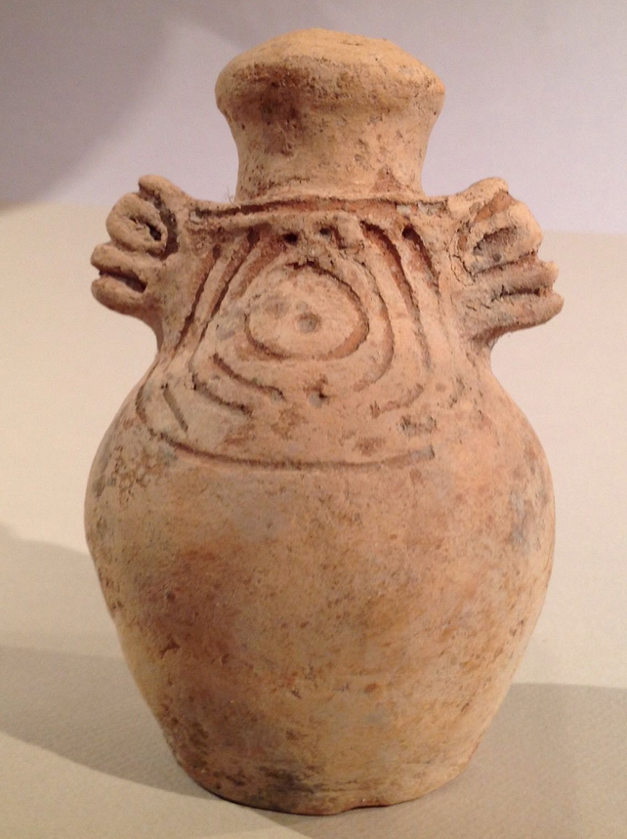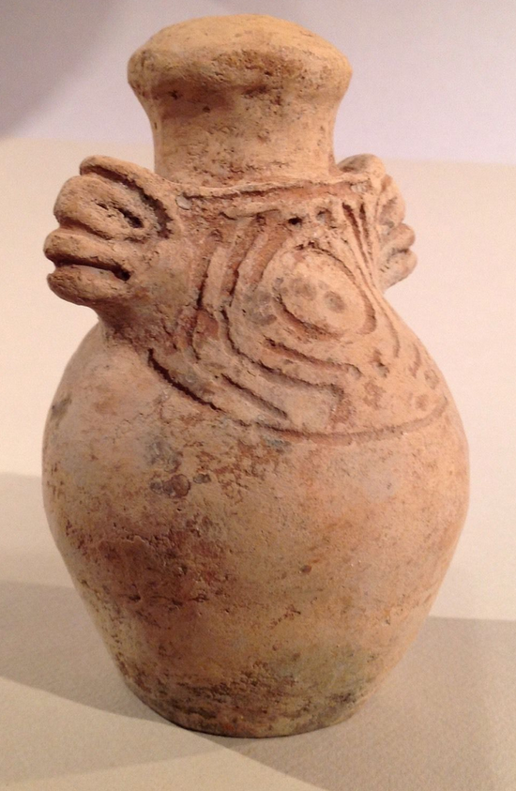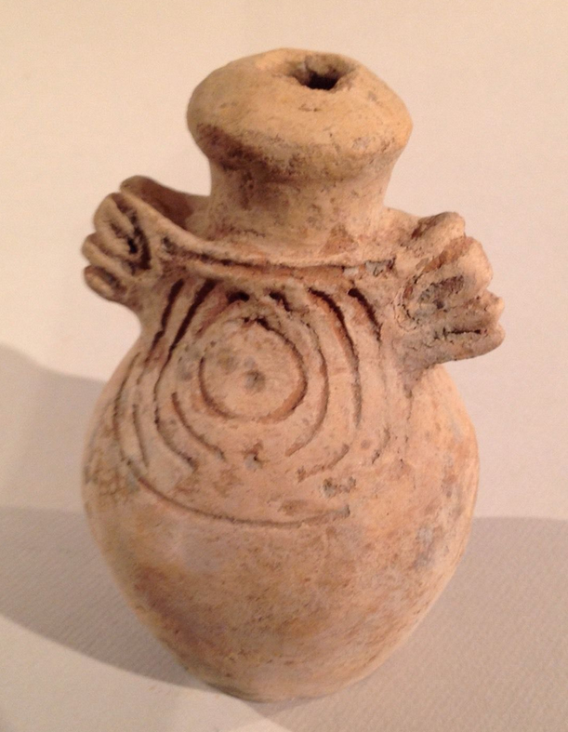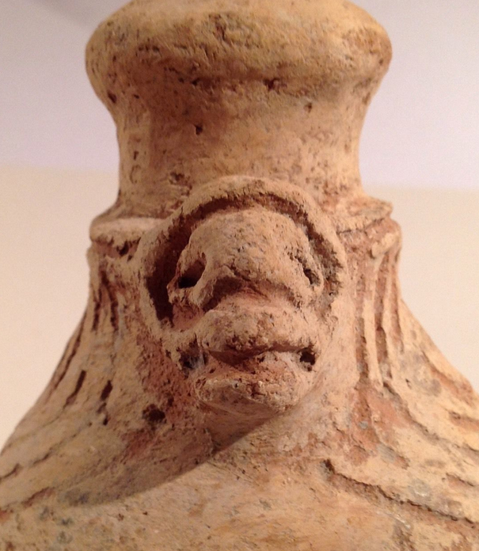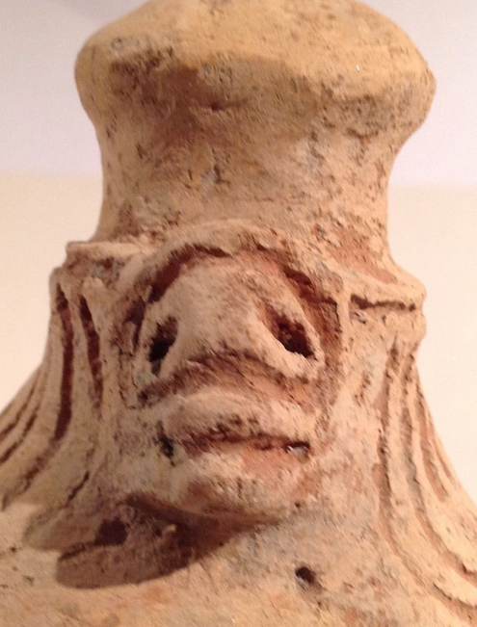

Figs. 1-5. Am,C-Taino-Potiza with two anthropomorphic heads of lovers--Terra cotta-1000 CE

**Case No.: 18**

**Accession No.**

**Formal Label:** Am,C-Taino-Potiza with two anthropomorphic heads of lovers--Terra cotta-1000 CE

**Display Description:**

### ****Potiza.**** Container used by the Aborigines of Quisqueyana to store water and fermenting the wine produced with the juice of Guáyiga. They were bought by women to men as a declaration of love. Taino pieces like this are normally described as bottles. Besides the 2 anthropomorphic heads of lovers the shoulders on both sides have concentric circle like incising. This is the symbol for perpetual energy or the sun.

**LC Classification:**

**Date or Time Horizon:**

**Geographical Area:** Originally from the Dominican Republic.

**Map:**

**GPS coordinates:**

**Cultural Affiliation:**

**Media:**

**Dimensions:** Height 14.7 cm. or 5.8 in.

**Weight:**

### Condition: original, There is no damage or repair of any kind.

**Provenance:**

**Discussion:**

**References:**